**Java Code**

1)

**class** Rectangle {

**int** length;

**int** breadth;

Rectangle(**int** l,**int** b) {

length = l;

breadth = b;

}

Rectangle getRectangleObject() {

Rectangle rect = **new** Rectangle(10,20);

**return** rect;

}

}

**class** RetOb {

**public** **static** **void** main(String args[]) {

Rectangle ob1 = **new** Rectangle(40,50);

Rectangle ob2;

ob2 = ob1.getRectangleObject();

System.***out***.println("ob1.length : " + ob1.length);

System.***out***.println("ob1.breadth: " + ob1.breadth);

System.***out***.println("ob2.length : " + ob2.length);

System.***out***.println("ob2.breadth: " + ob2.breadth);

}

}

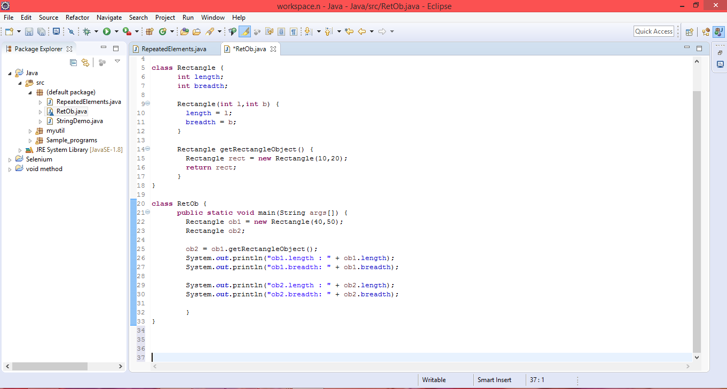

OUTPUT:

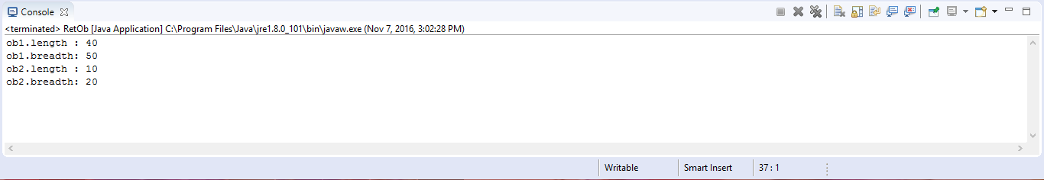

2)

**public** **class** StringDemo

{

**static** **int** *i*,*c*=0,*res*;

**static** **int** wordcount(String s)

{

**char** ch[]= **new** **char**[s.length()]; **for**(*i*=0;*i*<s.length();*i*++)

{

ch[*i*]= s.charAt(*i*);

**if**( ((*i*>0)&&(ch[*i*]!=' ')&&(ch[*i*-1]==' ')) || ((ch[0]!=' ')&&(*i*==0)) )

*c*++;

}

**return** *c*;

}

**public** **static** **void** main (String args[])

{

*res*=StringDemo.*wordcount*(" manchester united is also known as red devil ");

System.***out***.println("The number of words in the String are : "+*res*);

}

}

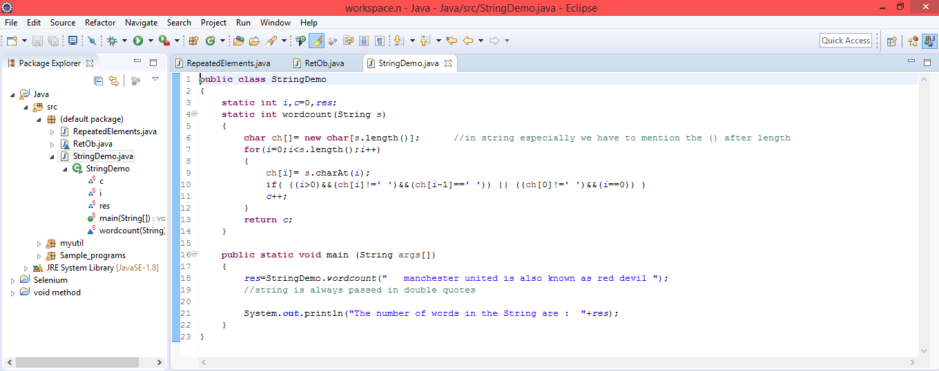

OUTPUT:

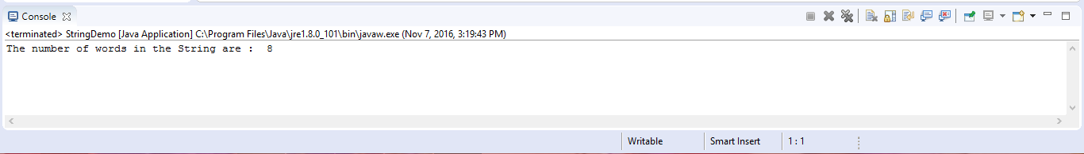

3)

**package** Sample_programs;

**class** Example1 {

**public** **static** **void** main(String args[]) {

**int** num1, num2;

**try** {

// Try block to handle code that may cause exception

num1 = 0;

num2 = 62 / num1;

System.***out***.println("Try block message");

} **catch** (ArithmeticException e) {

// This block is to catch divide-by-zero error

System.***out***.println("Error: Don't divide a number by zero");

}

System.***out***.println("I'm out of try-catch block in Java.");

}

}

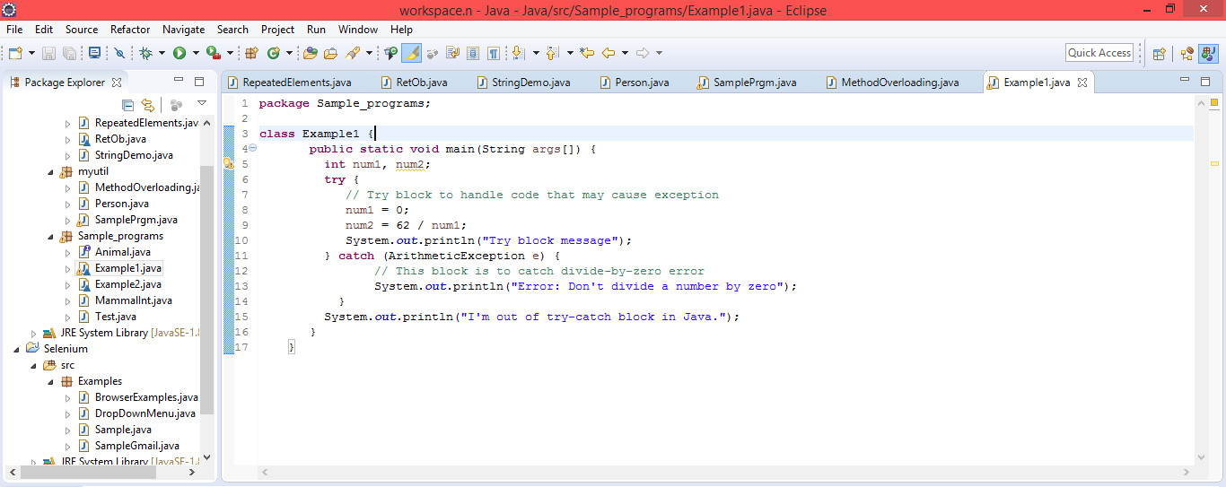

OUTPUT:

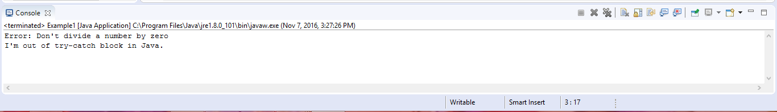

4)

**package** Sample_programs;

**class** Example2{

**public** **static** **void** main(String args[]){

**try**{

**int** a[]=**new** **int**[7];

a[4]=30/0;

System.***out***.println("First print statement in try block");

}

**catch**(ArithmeticException e){

System.***out***.println("Warning: ArithmeticException");

}

**catch**(ArrayIndexOutOfBoundsException e){

System.***out***.println("Warning: ArrayIndexOutOfBoundsException");

}

**catch**(Exception e){

System.***out***.println("Warning: Some Other exception");

}

System.***out***.println("Out of try-catch block...");

}

}

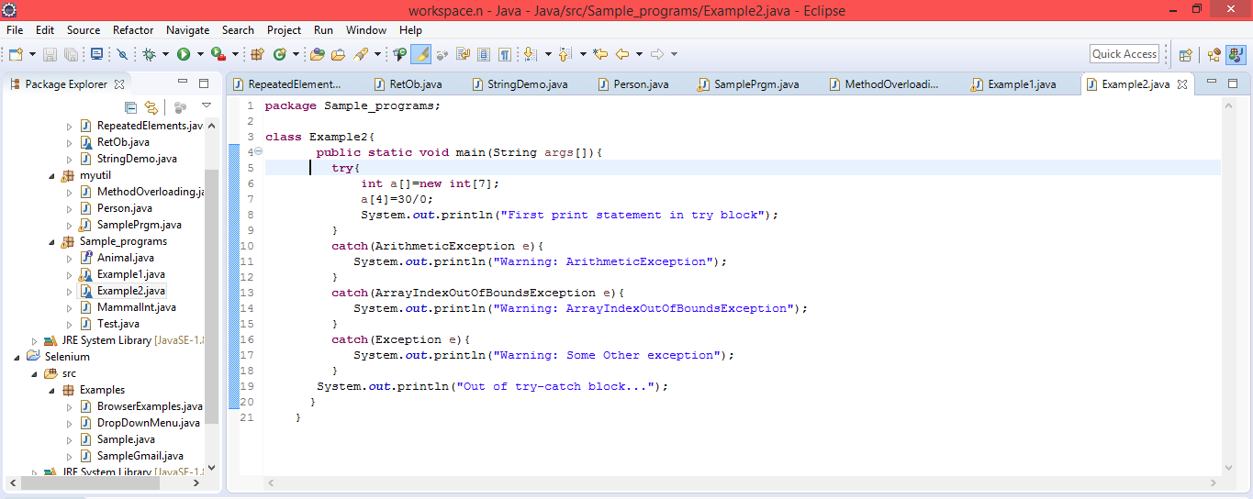

OUTPUT:

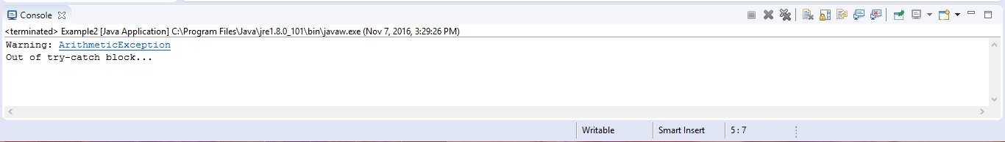

5)

**package** Sample_programs;

**public** **class** MammalInt **implements** Animal {

**public** **void** eat() {

System.***out***.println("Mammal eats");

}

**public** **void** travel() {

System.***out***.println("Mammal travels");

}

**public** **int** noOfLegs() {

**return** 0;

}

**public** **static** **void** main(String args[]) {

MammalInt m = **new** MammalInt();

m.eat();

m.travel();

}

}

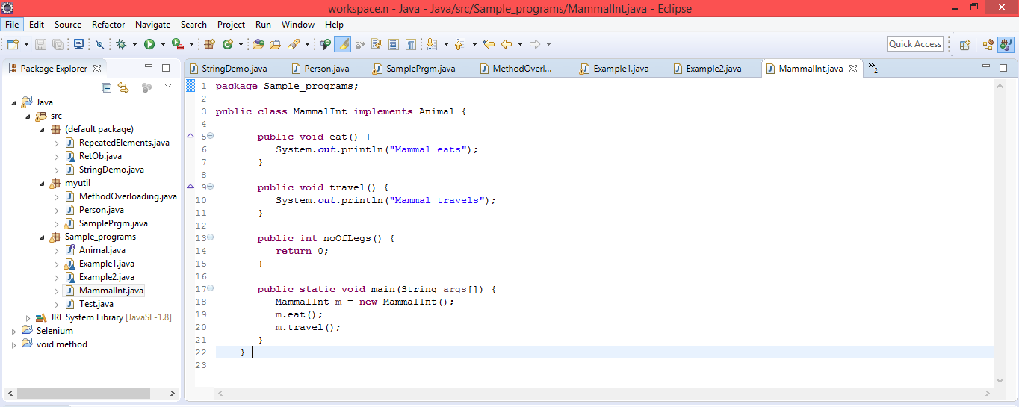

OUTPUT:

